Pharmacy Management System

(By SEMESTER – V OF 3 YEAR MSC(2021-22))

Submited By : Moinudin Kadiwal : 3106

Group ID : 51

Name of Company : BASU MEDICAL STORE

Date of Submission : 04/05/2022

Submitted To

K.S School Of Business Management

M.Sc – Computer Application And Information Technology

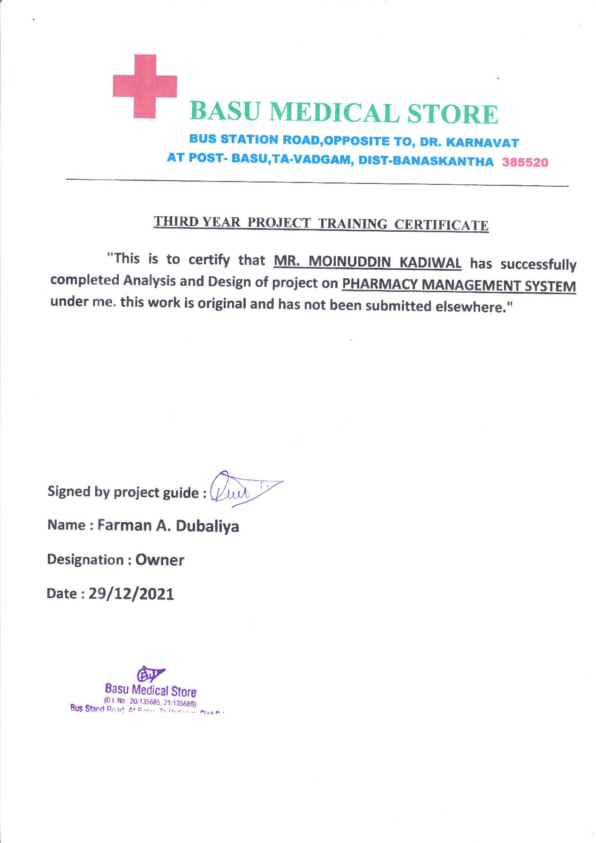

**ACKNOWLEDGEMENT**

We are thankful to K.S School Of Business Management for giving us an opportunity to learn several new concepts to this project and providing administrating help whenever needed. The feeling of acknowledge and expressing it in words are two things apart. we honestly admit when we truly wish to express our warm gratitude and indebtedness towards somebody, we are always at loss of word.

The project could not have completed without support extends to us by Hitesh sir, he guided us in preparation of the project and every time when we reached with difficulties, he welcomed them which helped us to successfully complete the project.

We acknowledgement the management staff of “Pharmacy Management System” for giving us permission to develop “Smart steel bidding and selling system” for business and helping us in understanding the current system which is a valuable input for developing the system.

With Regards, Moinudin Kadiwal

|  |  |  |  |  |
| --- | --- | --- | --- | --- |
| **No.** | **Title** | | | **Page** |
| **1.** | INTRODUCTION | | |  |
|  | 1.1 | Organization details | | 6 |
|  | 1.2 | System details | | 7 |
|  |  | 1.2.1 | Existing system |  |
|  |  | 1.2.2 | Proposed system |  |
|  | 1.3 | Scope of the system | | 7 |
|  | 1.4 | Objectives | | 8 |
| **2.** | PROPOSED SYSTEM REQUIREMENT GATHERING | | |  |
|  |  | Stakeholders of the system | | 9 |
|  |  | Requirement gathering technique used | | 10 |
|  |  | Consolidated list of requirement | | 12 |
|  |  | Project definition | | 12 |
| **3.** | SYSTEM MANAGEMENT AND PLANNING | | |  |
|  | 3.1 | Feasibility study | |  |
|  |  | 3.1.1 | Technical study | 14 |
|  |  | 3.1.2 | Economical study | 14 |
|  |  | 3.1.3 | Operational study | 14 |
|  | 3.2 | Hardware-software requirement | | 15 |
|  | 3.3 | System planning | | 15 |
|  |  | 3.3.1 | Work breakdown  structure | 16 |
|  | 3.4 | Process model | | 17 |
| **4.** | System Analysis and Design | | |  |
|  | 4.1 | UML(Unified modelling language) | |  |
|  |  | 4.1.1 | Use Case | 18 |
|  |  | 4.1.2 | Activity Diagram | 19 |
|  |  | 4.1.3 | Class Diagram | 20 |
|  | 4.2 | System flow diagram | | 21 |
|  | 4.3 | User Interface | |  |
|  | 4.4 | Data dictionary | | 22 |
|  | 4.5 | System navigation | | 26 |
| **5.** | Input/Output Design | | | 27 |
| **6.** | Testing | | |  |
| **7.** | Summary | | |  |
|  | 7.1 | Assumption | |  |
|  | 7.2 | Limitations | |  |
|  | 7.3 | Future Scope | |  |
|  | 7.4 | Conclusion | |  |

## CHAPTER – 1

### INTRODUCTION

The purpose of this project is to build " Smart Pharmacy Management & Billing System ”, It deals with the automating tasks of maintaining of Bills and stock of Medicines. In Pharmacy Billing Management is the key process. Including safe data store about medicine as well as fast searching , delete and Update of medicines. The Pharmacy Management System is built for the sake of ensuring effective and dear data Saving and manipulating as well as neat work on the Pharmacy medical products.

In general, The Pharmacy Management System is based on computer technology that gives service for users, Managed by the Pharmacist who give implementation of function relatively in effective times as well as will design for removing time wasting, saving resources, easy data access of the medicine, security on data input and data access by removing almost manual based System.

* 1. Organization profile

" Basu Medical Store " established in 2001, run by Farman A. Dubaliya provide Medicine to Patient. It manage the stock of Medicine and provide medicine to patient without any System.

|  |  |
| --- | --- |
| Name : | Basu Medical Store |
| Address : | Basu Station Road ,Opposite To  ,Karnavat, At Post-Basu, Ta-Vadgam, Dist - Banaskantha |
| Name: | Farman A. Dubaliya |
| Mobile No: | +8401245761 |

### System Details

###### Existing System

Used for describing something that exists now, especially when it might be changed or replaced. The existing system needs to be change.

* In existing system, there is lots of paper work and calculation. So, its may occur an error.
* The existing System consume lot of time.
* he data which is store on paper exclusively therefore maybe lost, stolen and destroyed due to some situation.
* The number of retailers have increasing every year therefore maintaining and retrieving details of retailers is very difficult.

###### Proposed System

The proposed system should have the following features. The transactions should take place in a secured format between various clients in the network. It provides flexibility to the user to transfer the data through the network very easily.

* We can utilization of time and workforce.
* We can achieve high accuracy in calculation.
* We can store our shortage of data till long term.
* we get efficiency in modification, sorting and retrieval of data.

### Scope of System

With the development of specific and potent synthetic drugs, the emphasis of the pharmacist responsibility has moved substantially towards the utilization of scientific knowledge in the proper use of modern medicines and the protection of the public against dangers that are inherent in their use.

* Our system manages the stock of Medicine.
* Do Operation like insert medicine, Delete Medicine Update Medicine.
* In our System make generate report for selling, expensive.
* Make bill for Customer on buying medicine.
* Manage The company details.

### Objectives

The "Pharmacy Management & Billing System" that will be used for maintaining the records in an organized manner and to replace all paper work system.

* It is the User friendly application for Pharmacist. Which reduces the burden and help to Manage all sections of pharmacy like Medicine Management and Billing etc.
* It deals with the automating tasks of maintaining of Bills.
* In Pharmacy, Bill Management is the process, Including safe data store about medicine as well as fast searching , Delete and Update of medicines.
* The Pharmacy Management System is easy for use so the user can do pharmacy action without ambiguities.
* This refers the pharmacy management system project highly minimize time and resource by which and searching the medicine data you can get the data in quickest time.
* The pharmacy management System is built for the sake of ensuring effective and dear data saving and manipulating as well as neat work on the pharmacy medical products.

## CHAPTER – 2

##### . PROPOSED SYSTEM REQUIREMENT GATHERING

Every software project goes through a phace called requirement gathering. A successful project begins with a difficult set of discussion on what should be done. Its major responsibility of IT business analysis to gather the requirement from the client. Getting the correct requirement from the client can often be one of the biggest hurdles in any software project. If business analysis gathers correct and complete requirements, the project will yield richer crops

* + 1. Stakeholder of system

Each of these groups of people has its own requirements, interests, and needs to be met by the software system. We refer collectively to these people as stakeholders. Understanding the role of the stakeholder is fundamental to understanding the role of the architect in the development of a software product or system.

DEFINITION OF STAKEHOLDER

"Anyone who interact with the system is known as Stakeholder. Stakeholder takes benefits in a direct or indirect way from the system. The stakeholder in the architecture of a system is an individual, team, organization, or classes thereof, having an interest in the realization of the system."

### THE FOLLOWING ARE THE STAKEHOLDER OF THE SYSTEM▪

1. **Admin :-**
   * Admin observe day to day activity of the shop at every level. Admin maintain the whole system.
   * Admin Can Manage The stock of Medicine, Admin can Add the Medicine, Remove the Medicine and Update The Medicine.
   * Admin Generate Bill for Customer On buying Medicine.
   * Admin can add and remove employee and maintain their profile.
   * Admin can also generate the report of whole system.

### Manager :-

* + Manager Can do Daily Activity Like Generate The Bill for Customer, Generate The Expensive Report for Pay and generate report for sells.
  + Manager Can not manage The stock of Medicine.

###### Requirement Gathering Techniques Used

Primarily done during stakeholder meetings, requirements gathering is the exploratory process of researching and documenting project requirement. Shockingly, more than 70 percent of failed projects miss the mark due to a lack of requirements gathering. That no small number.

Data collection method or fact gathering techniques which are used while gathering the information about "Smart steel bidding and selling system". There are many techniques are available for gathering requirement. Sometimes, it is necessary to use multiple techniques to gather complete and corrects requirement from the client and user.

* + - * FOR GATHERING THE REQUIREMENT THERE ARE SOME TECHNIQUES THEY ARE AS BELOW:

1. Interviews:-
   * Interviews of users and stakeholders are important in creating wonderful software and the most common techniques for gathering requirements is sit down with the user and ask them what they want from the system.
   * Ask open-ended questions to get the interviewee to start talking and then ask probing question to uncover requirements.
2. Observation:-
   * The observation covers the study of users in its natural habitat.
   * Observation can either be passive or active.
   * By watching Pharmacist how he face the errors and which error ,I solve this facing error and make application better then previous application.
3. Questionnaires:-
   * Questionnaires are more informal, and they are good tool to gathering requirements from the stakeholder in remote locations or those who will have only minor input the overall requirements.

### The technique is used by us for our project which is shown below:

**INTERVIEW**

We had held an interview with the owner of the shop for the requirements of our system and the following questions asked.

1. Are you using any kind of system for Manage stock of Medicine and generate the Bill ?
   * No, there is not existing any kind of system for our Shop.
2. What problem are you facing to Manage stock of Medicine ?
   * So many Paper Work, time consuming.
3. What requirements do you want in the proposed system ?
   * Bill generation, report generation & Manage Medicine Stock.
4. Which Functionality you want to add your System ?
   * We want to add Advance Searching, Data Store on Cloud, Better Security and Other useful Functionality.
5. You Generate The Bill for Your Customer ?
   * Yes, we generate bill with proper details of customers and medicines.

##### CONSOLIDATED LIST OF REQUIREMENT

* + Admin can manage overall Application and his profile.
  + Admin can generate a report of whole the system.
  + Admin can Manage the stock of Medicine, he/she can Add, Delete, Update The Medicine.
  + Admin can Generate the report on sells & expensive.
  + Admin can manage the Company Details.
  + Manager can generate the Bill for Customer, generate the reports
  + Manager can Not Manage The stock of Medicine , Only Admin can Access the Admin section.
  + Admin can change System logo and Information.
  + Admin can manage all the products for auction or the selling.
  + It should be update at each and every second.
    1. **PROJECT DEFINITION**

###### User-Friendly :



Is the way the built System tem is not ambiguous which is clear for using the created software interface for manipulating actions or tasks. In the other way the proposed System is designed for human likable components in color, font and other related things.

###### Manual based System :



The system that uses was paper based and arranged on the shelf through functionality of documents. Everything that is arranged, searched, updated and deleted is through humans only. In general manual based system.

###### Pharmacist :



The profession who have knowledge on the medicine usage, instruction for use those medicines for the particular diseases and other related things.

###### Management System :



1. Admin

A System in which manage, organize, formulate data’s through a technical data structure arrangement.

###### Billing :

The way in which generating paper which store information about some specific data containing details explanation.

1. Manager

CHAPTER – 3

SYSTEM MANAGEMENT AND PLANNING

* 1. Feasibility Study

The feasibility study is carried out to select the best system that meets performance requirements. The main aim of the feasibility study to determine that it would be financially and technically feasible to develop the product or not. The purpose of feasibility study is not to solve the problem but to determine whether the problem is worth solving.

* + 1. Technical feasibility

The technical feasibility study compares the level of technology available in the software development form and the level of technology required for the development of the product. Here, the level of technology consists of the programming language, the hardware resources, other software tools, etc

* + 1. Economic feasibility

The economic feasibility study evaluates the cost of the software development against the ultimate income or benefits gets from the developed system. There must be scope for profit after the successful completion of the project

* + 1. Operational feasibility

Operational feasibility study tests the operational scope of the software developed. It is checked that if the system is actually can be usefull when implemented and how it satisfies the requirements identified in the requirements analysis phase of system development.

* 1. Hardware-Software Requirement

Software Configuration :

|  |  |
| --- | --- |
| Requirements | |
| Operating System | Windows, Linux, Mac |
| DataBase | Java DB |
| Runtime Environment | netBean |
| Back-end Tool | Java |
| Front-end Tool | JAVA |

* 1. System Planning

#### Work Breakdown Structure:

* + - * Dividing complex projects to simpler and manageable tasks isthe process identified as Work Breakdown Structure.
      * Usually, the project managers use this method for simplifying the project execution. In WBS, much➢ Larger tasks are broken down to manageable chunks of work. These chunks can be easily supervised and estimated.

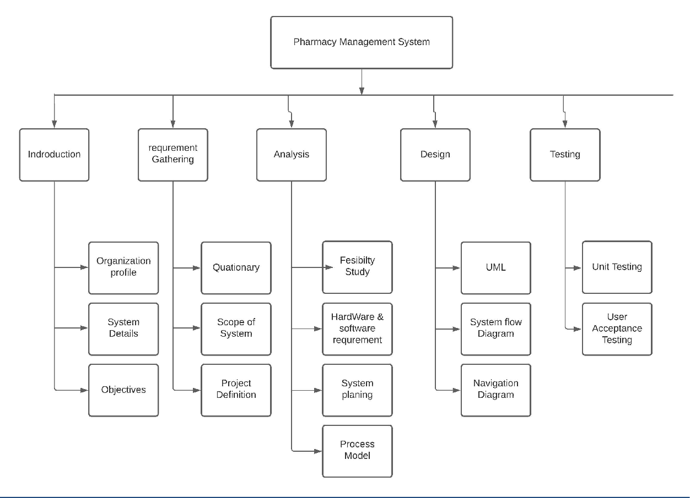

# Process model

As new requirements can arise in future incremental models are used. With the help of it we can fulfill maximum user requirements. In every increment the needs of the client are kept in mind and more features and functions are added. These increments form a base for customer evaluation. Many features can be added after the development of the system that serves the main purpose. If there is a smaller number of employees to work on the project Incremental development model is very useful to complete the project before the deadline.

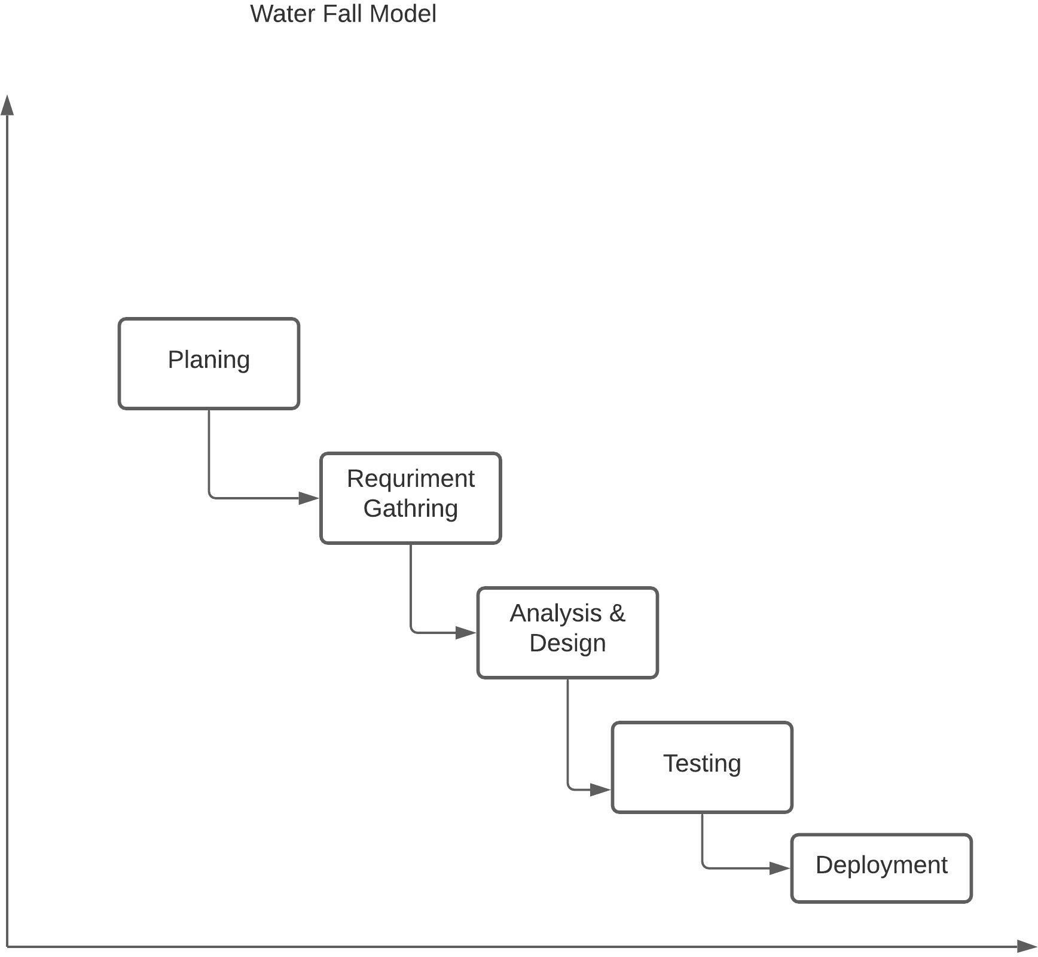

# CHAPTER – 4

4. SYSTEM ANALYSIS AND DESIGN

#### UML :

* + 1. Use Case:
       - Admin :

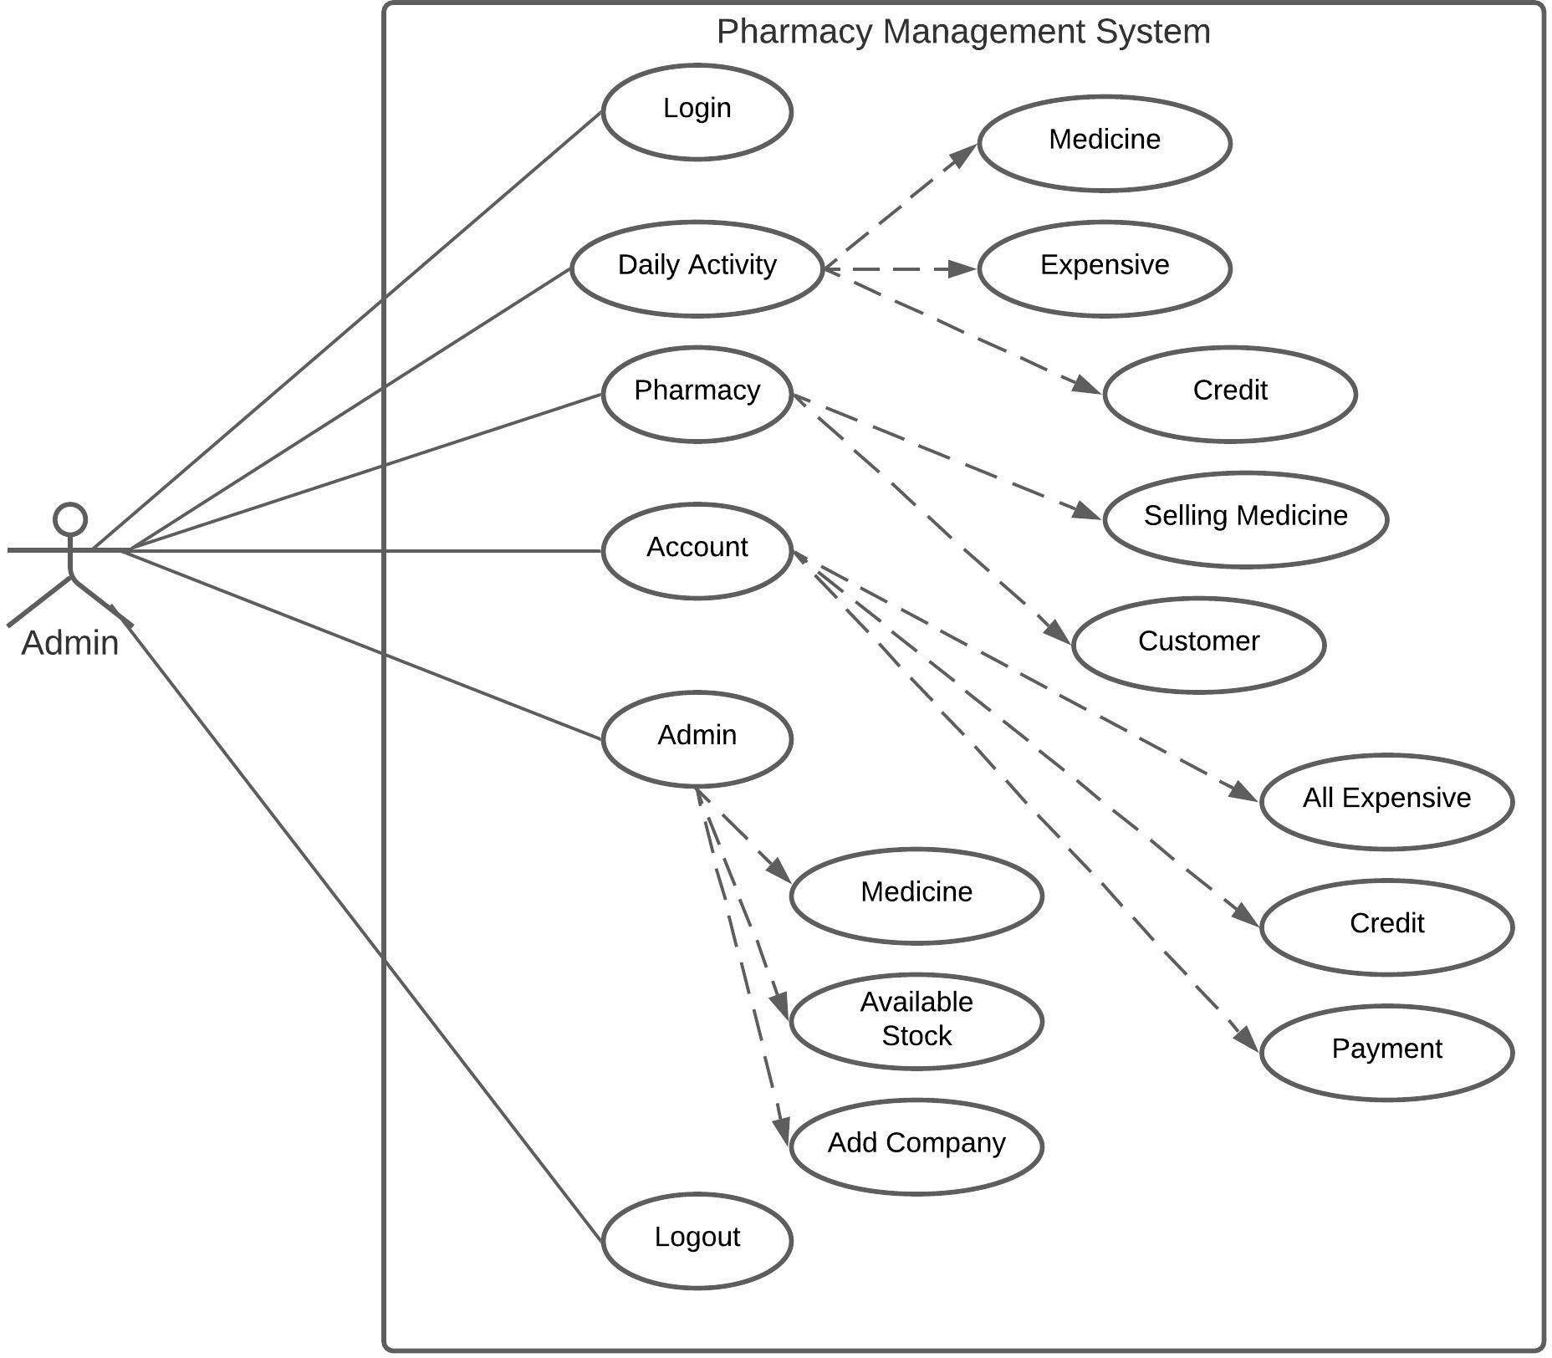

#### Activity Diagram:

* + - * Admin :

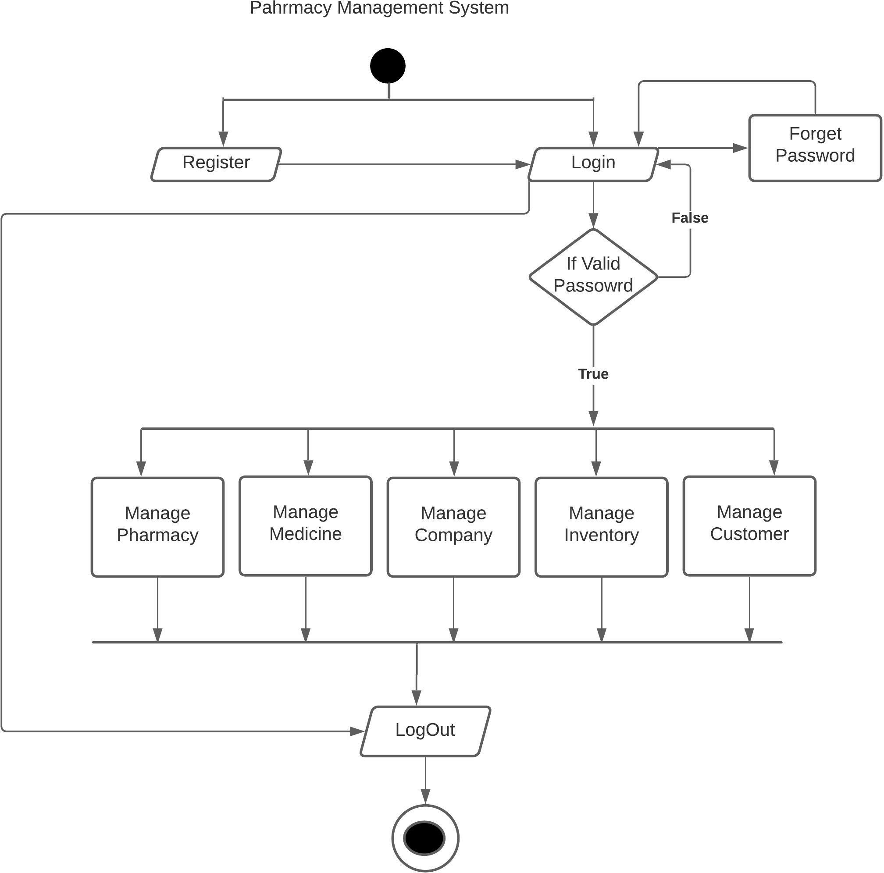

* + 1. Class Diagram :

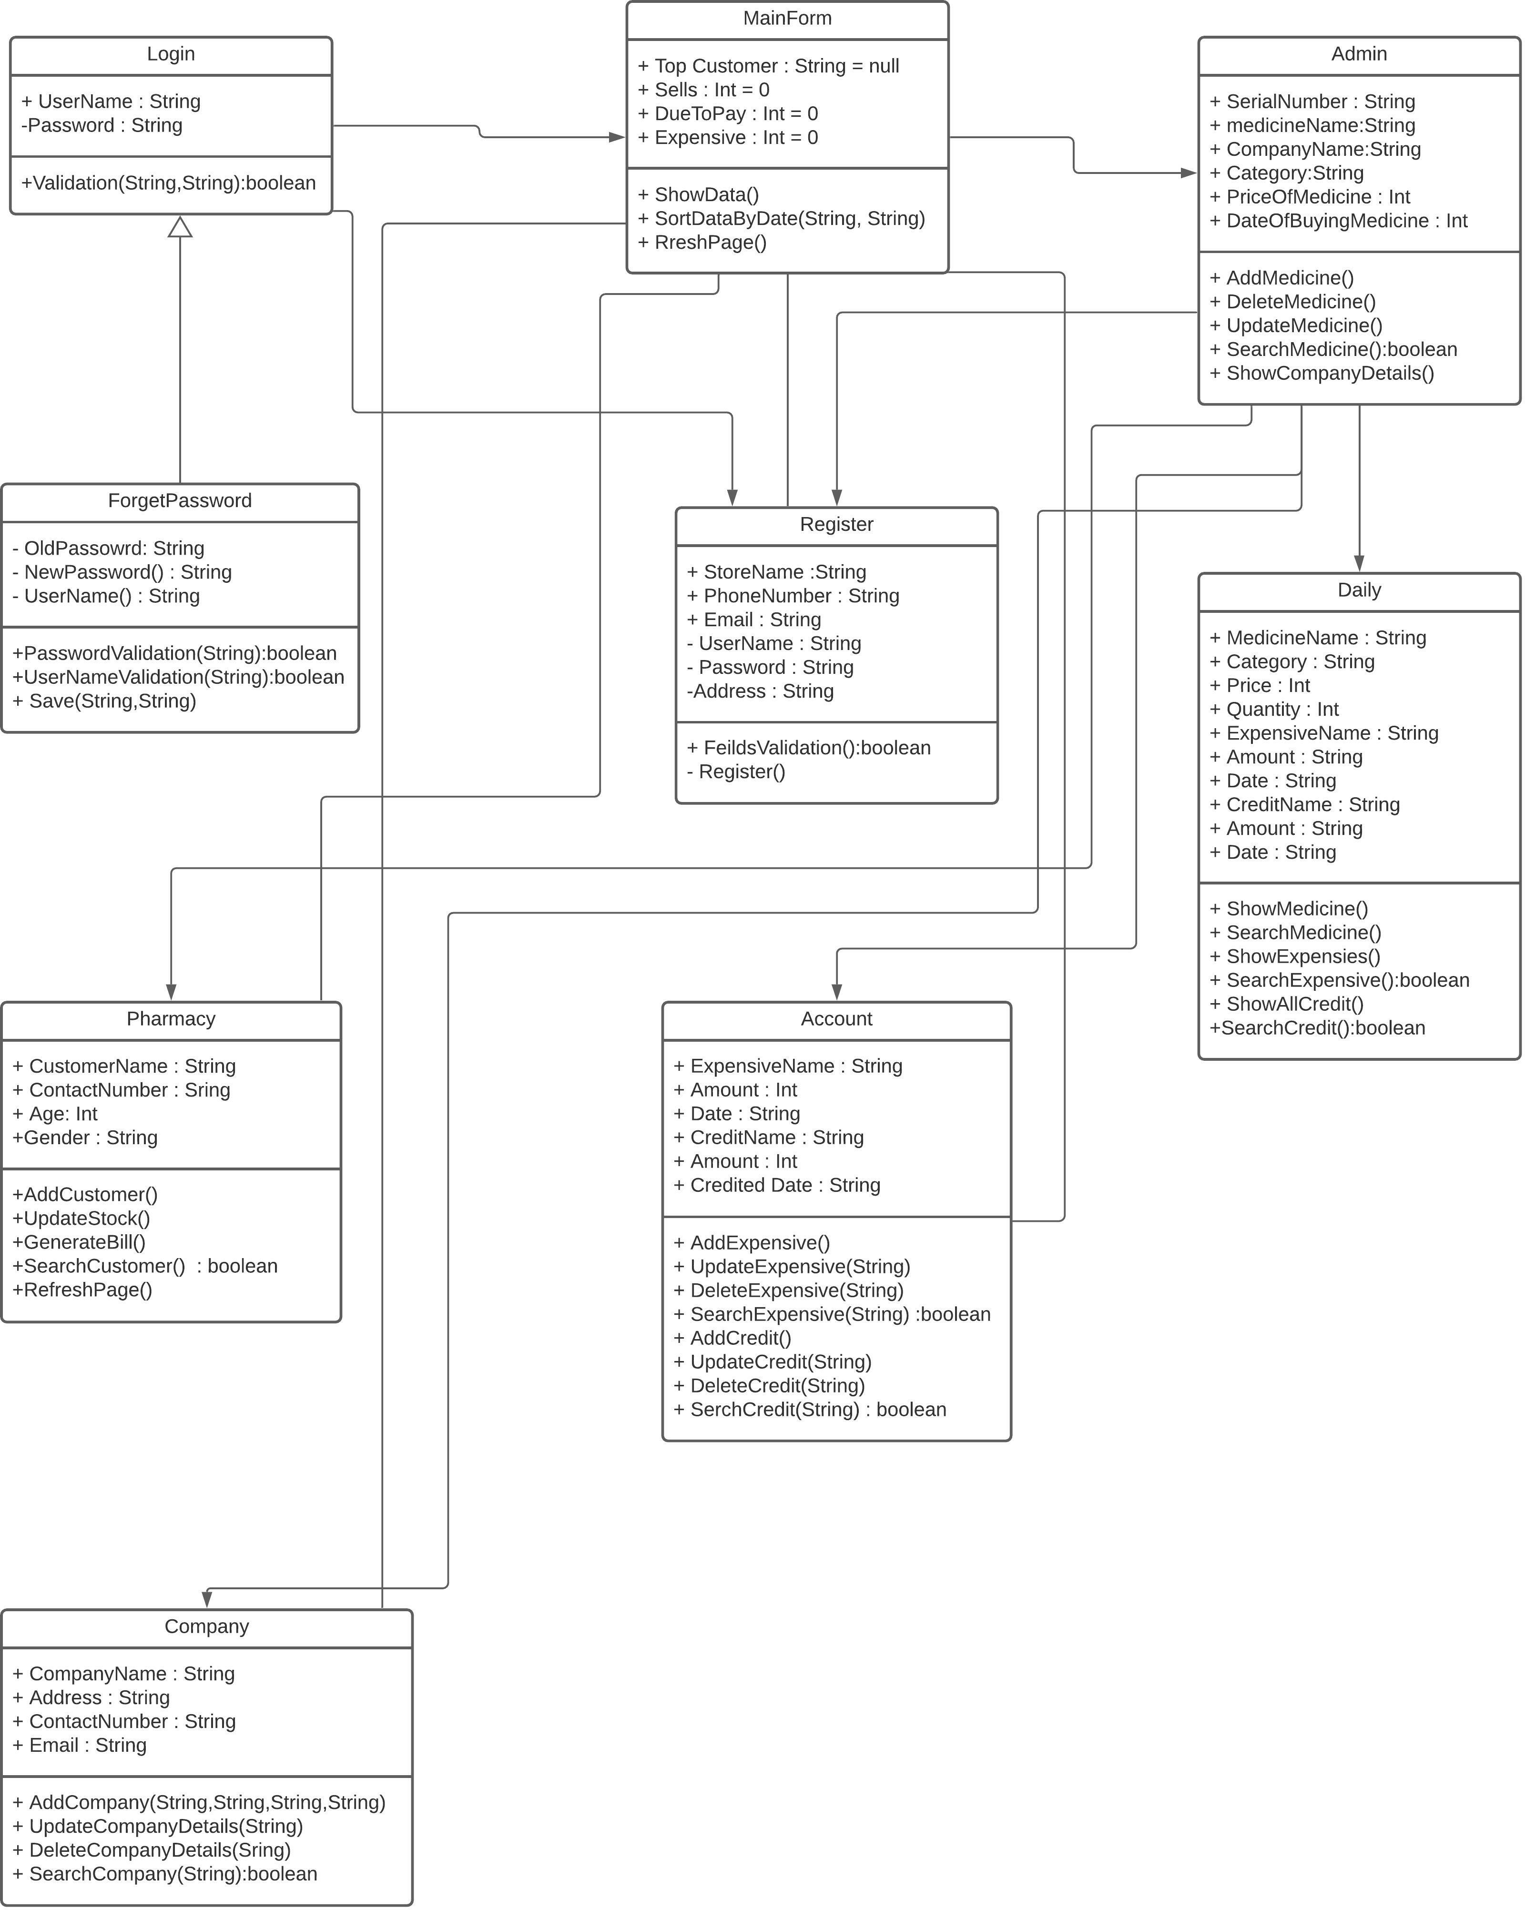

* 1. System Flow Diagram :

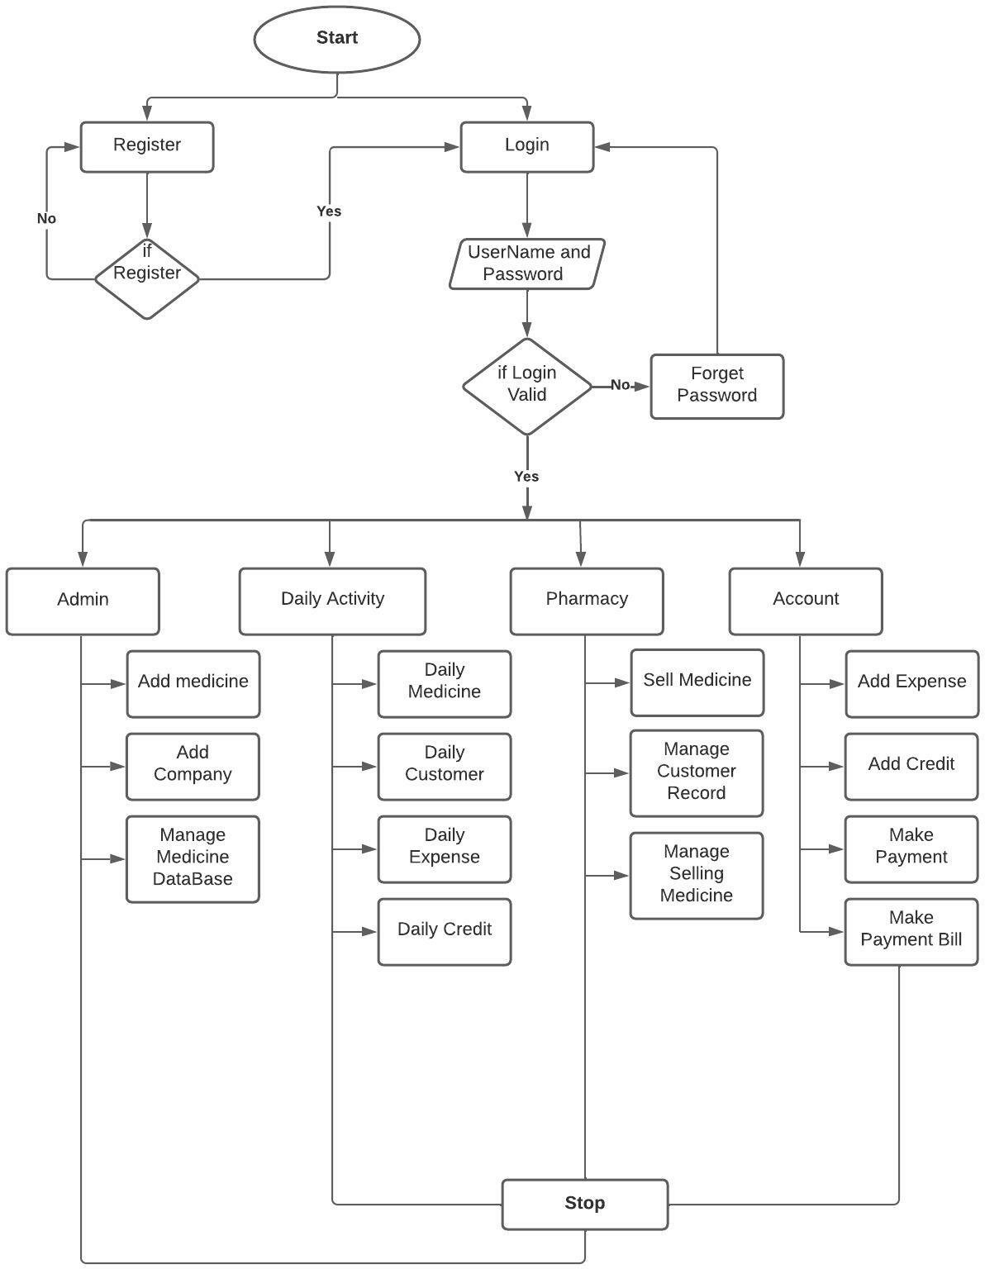

* 1. Data Dictionary :
     1. Medicine Table :

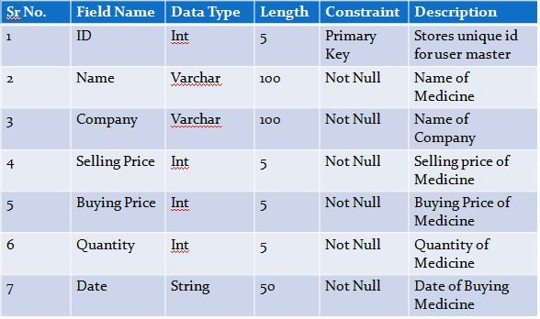

* + 1. Company Table :

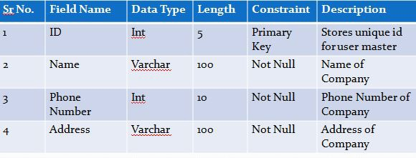

* + 1. Customer Table :

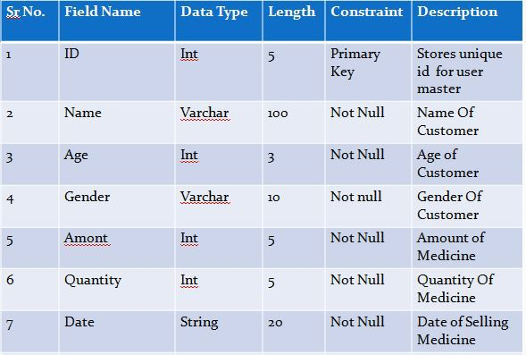

* + 1. Expensive Table :

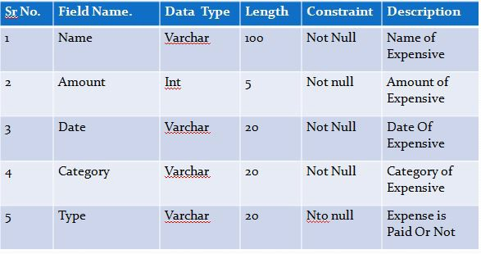

* + 1. Credit Table :

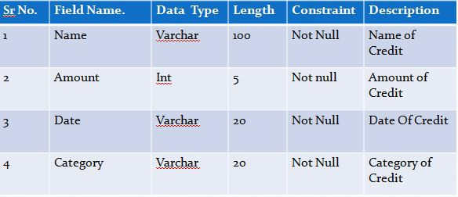

* + 1. Selling Medicine :

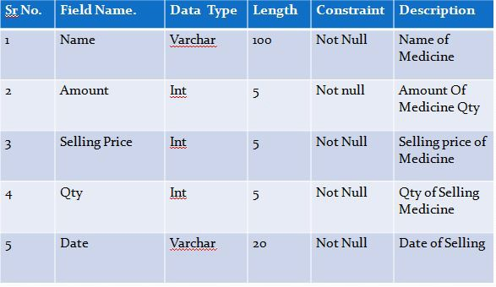

4.4 System Navigation :

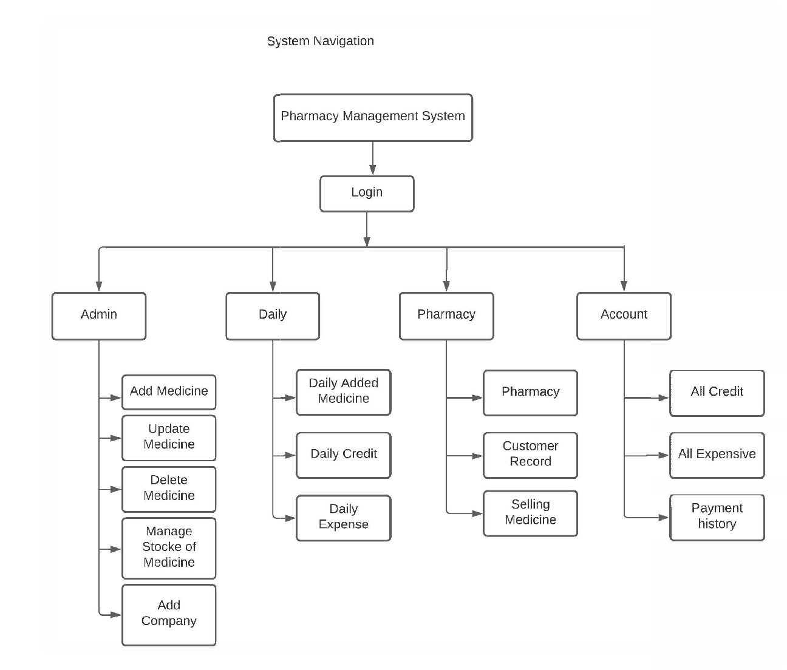

4.5 User Interface:

# CHAPTER – 5

4. SYSTEM ANALYSIS AND DESIGN

1. Register :

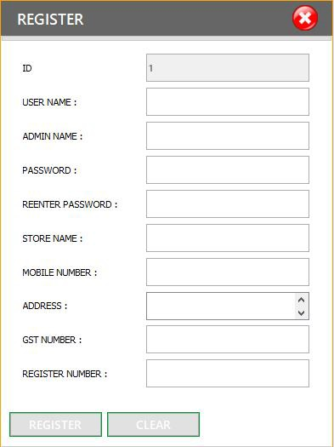

1. Login :

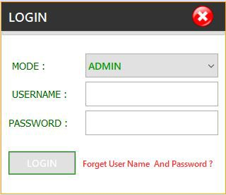

1. Forget Password :

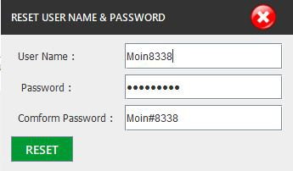

1. Home Page :

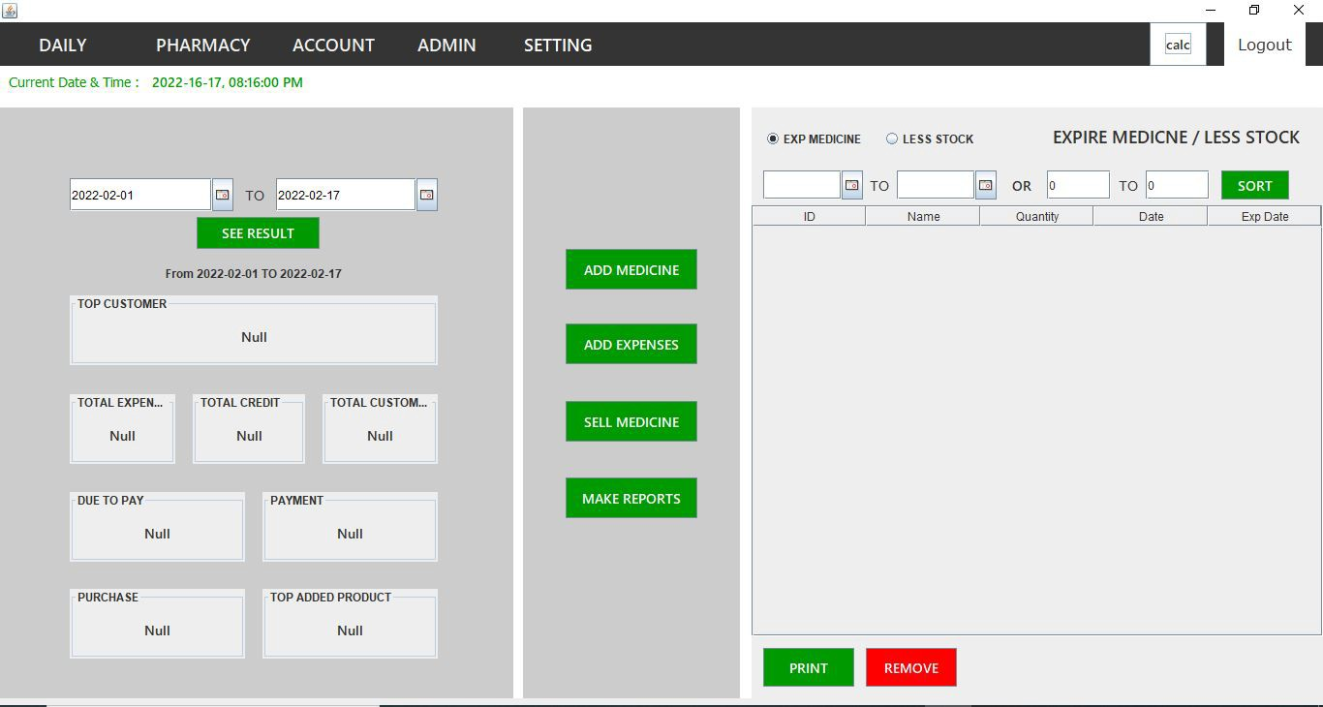

1. Admin :
   1. Medicine :

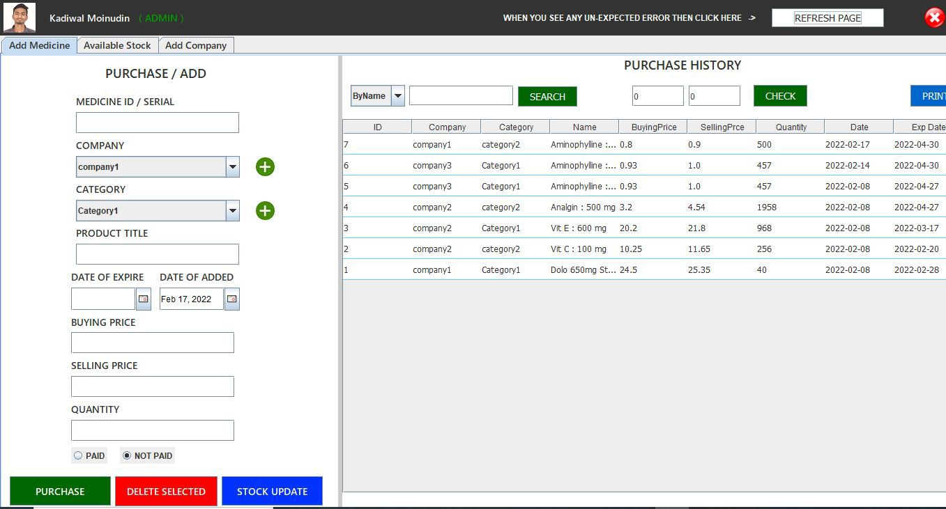

* 1. Print Medicine Statement :

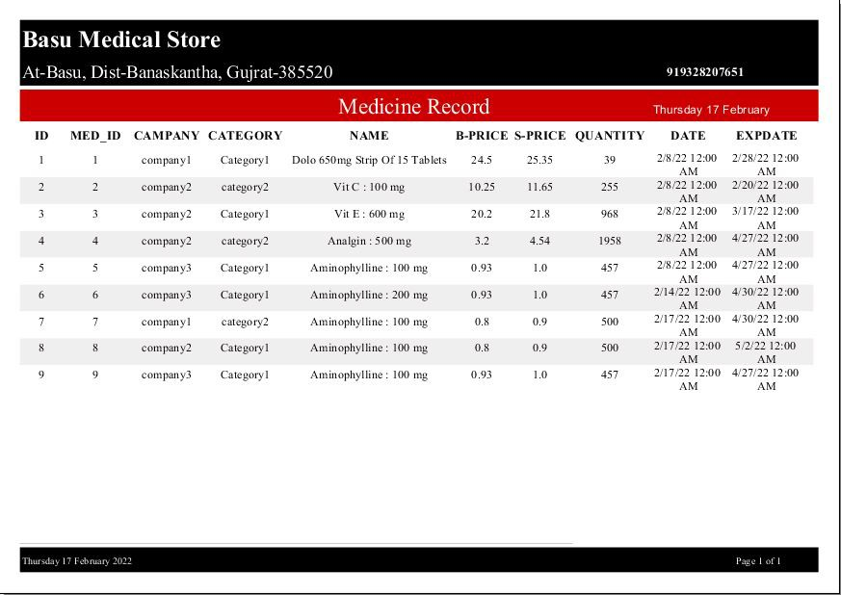

* 1. Available Stock :

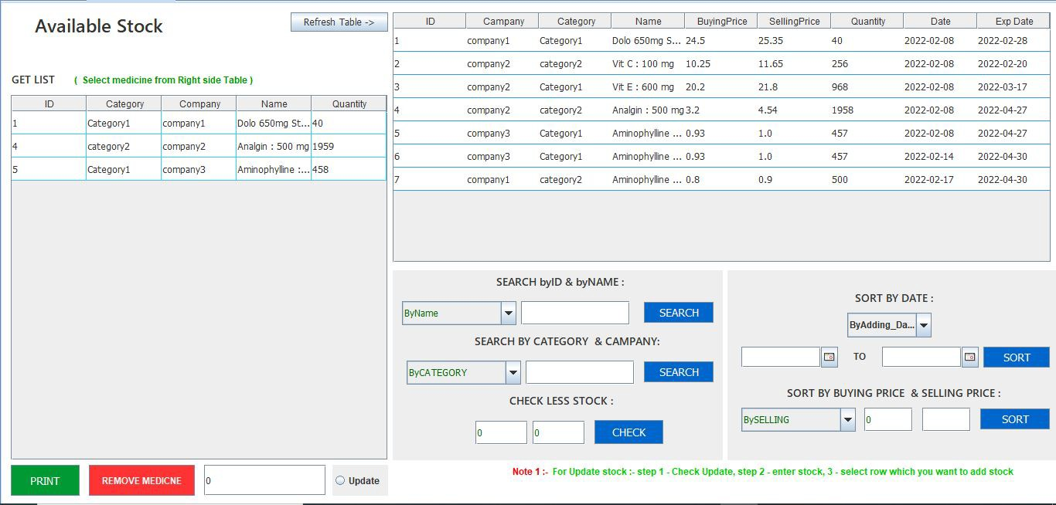

* 1. Add Company :

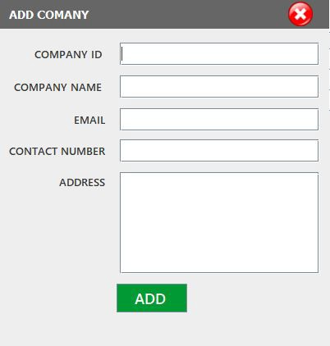

* 1. Company :

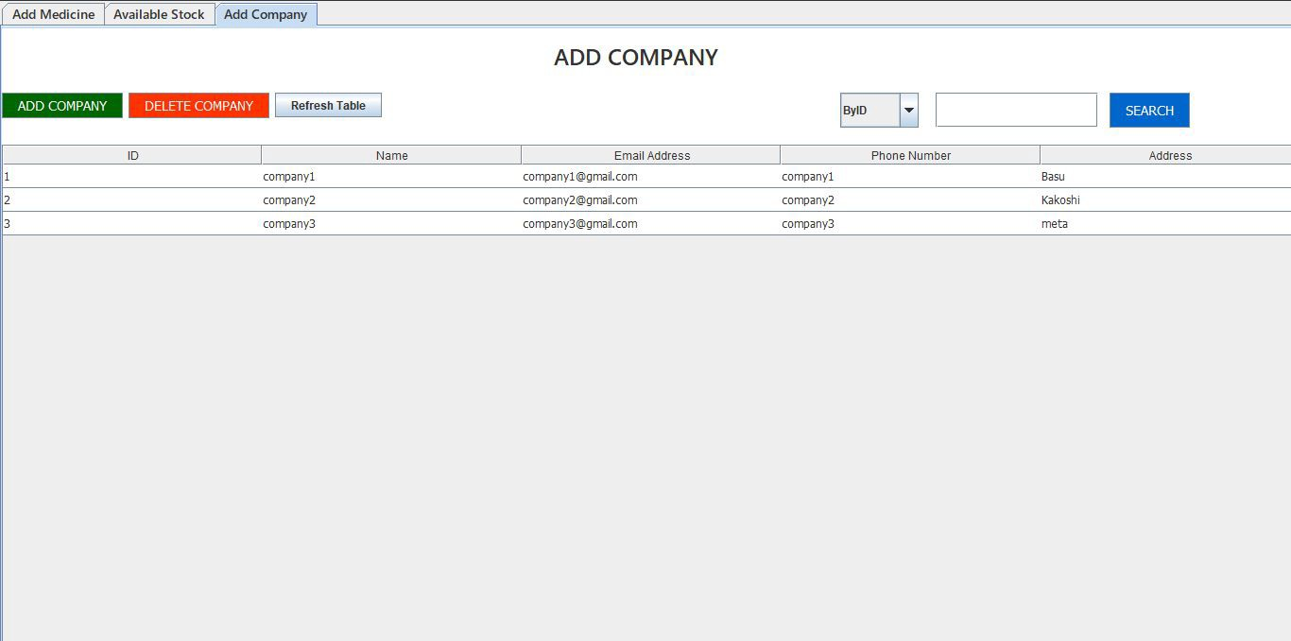

1. Daily Activity :
   1. Daily Medicine :

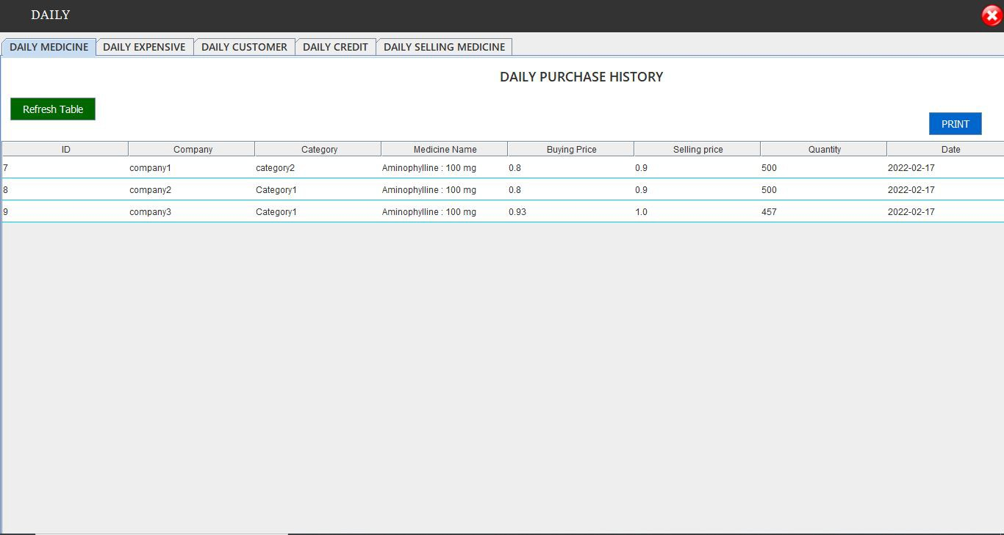

* 1. Daily Expense :

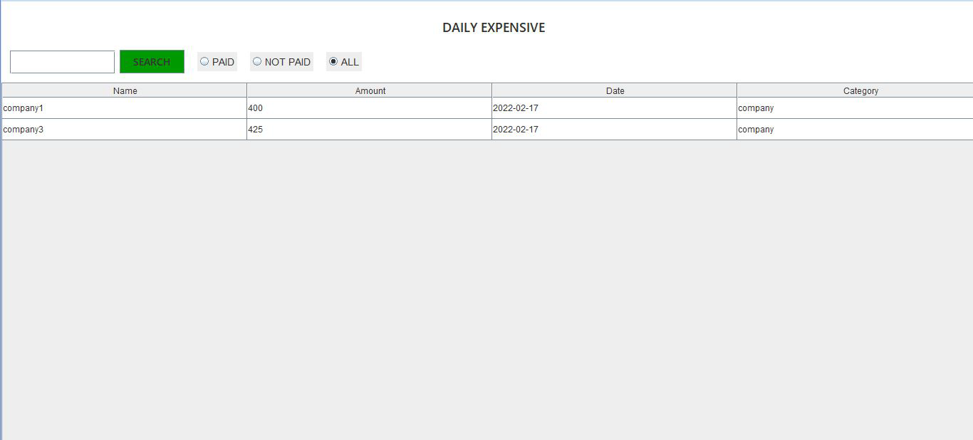

* 1. Daily Customer :

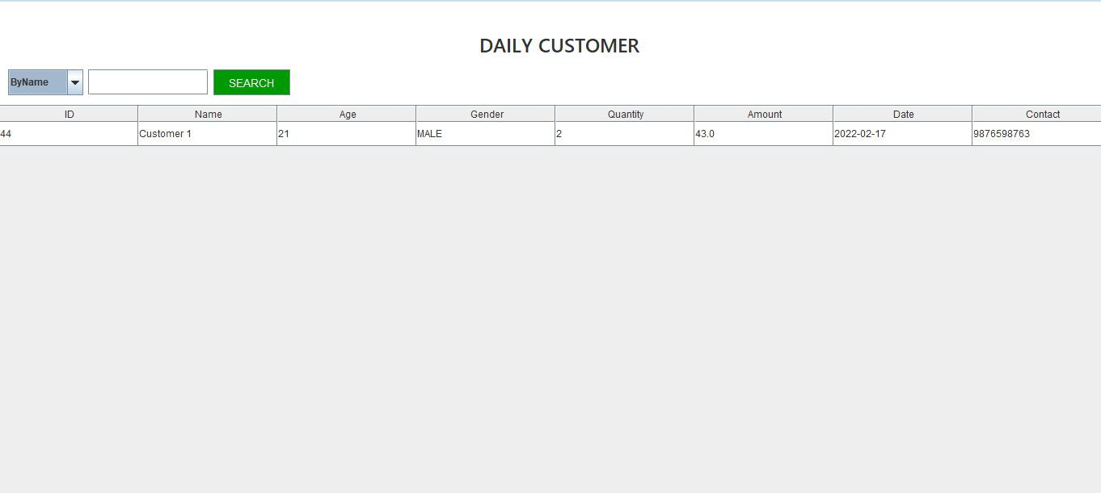

* 1. Daily Credit :

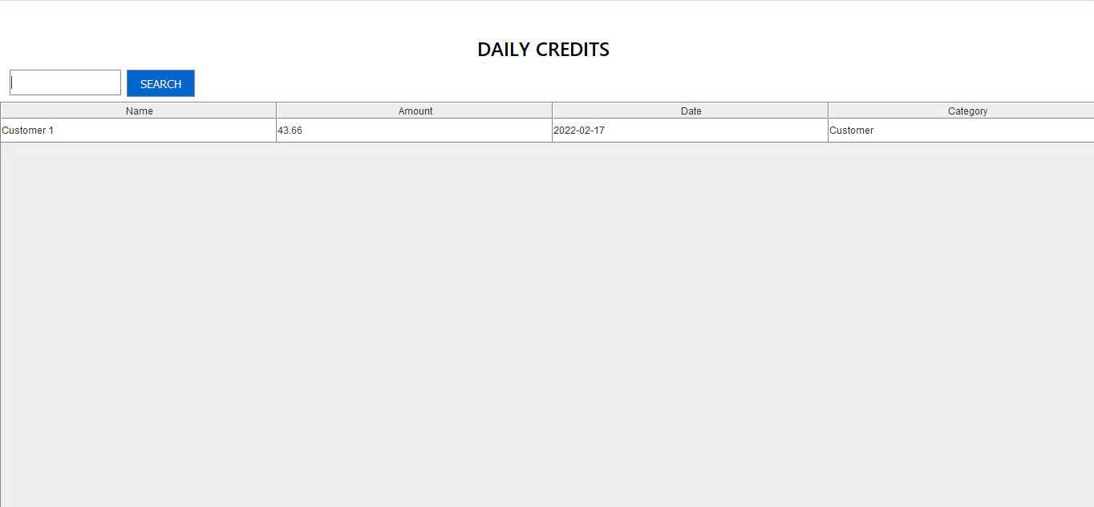

1. Pharmacy :
   1. Sell Medicine :

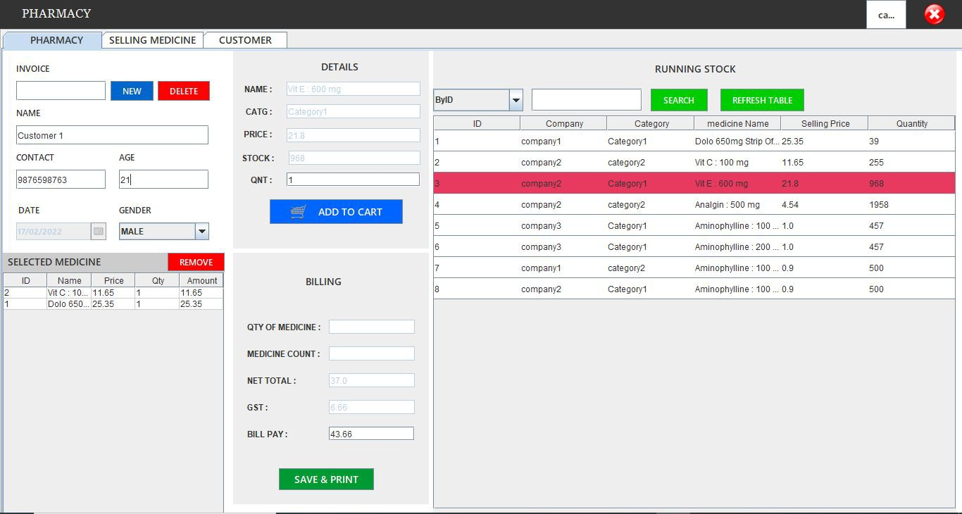

* 1. Customer Invoice :

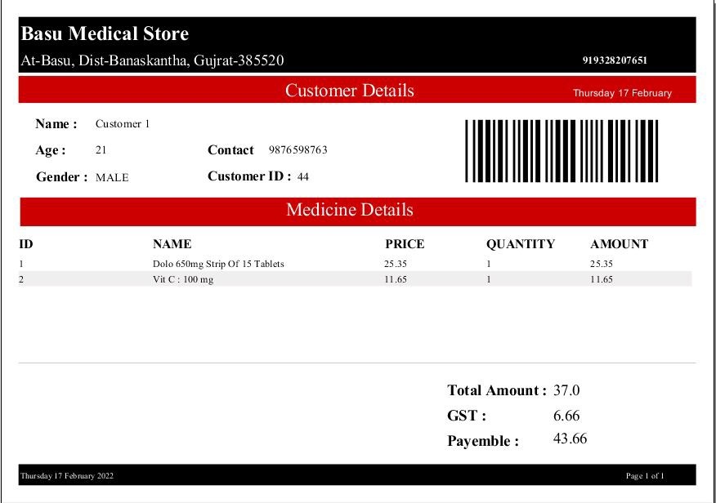

* 1. Selling Medicine :

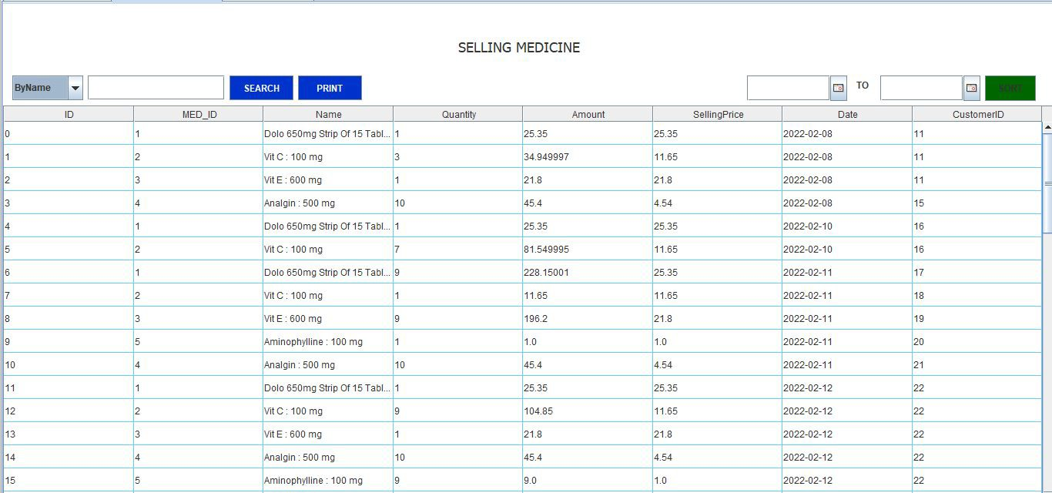

* 1. Print Selling Medicine Statement :

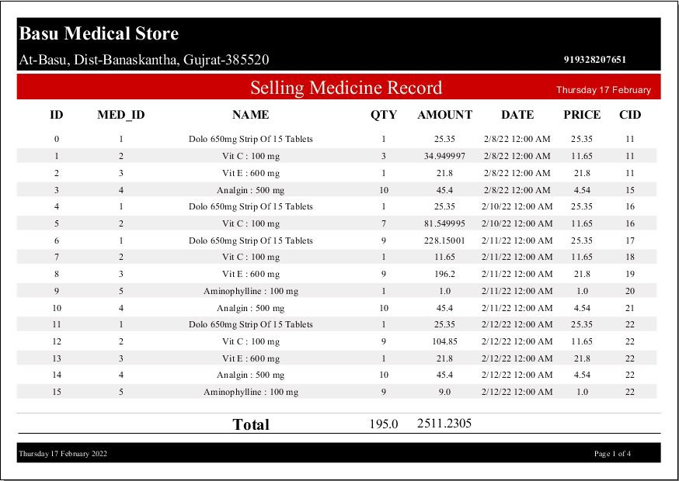

* 1. Customer Records :

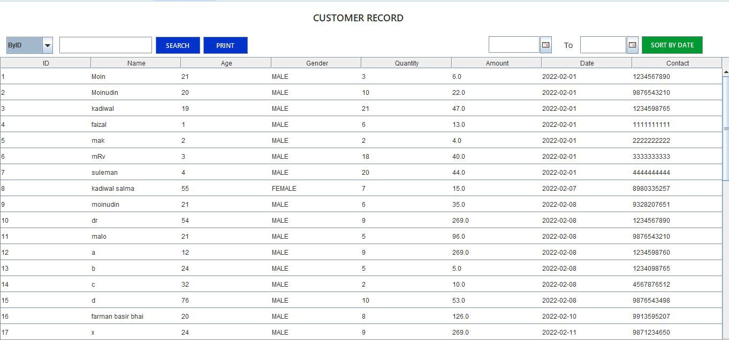

* 1. Print Customer Statement :

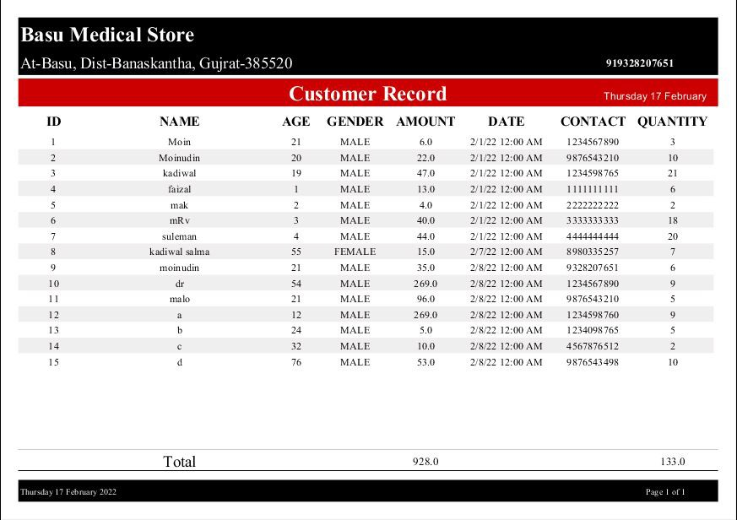

1. Account :
   1. Expense :

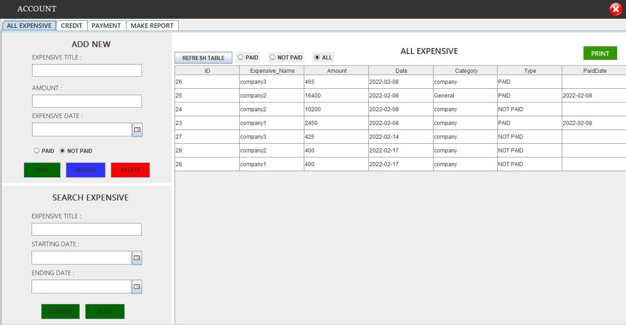

* 1. Print Expense Statement :

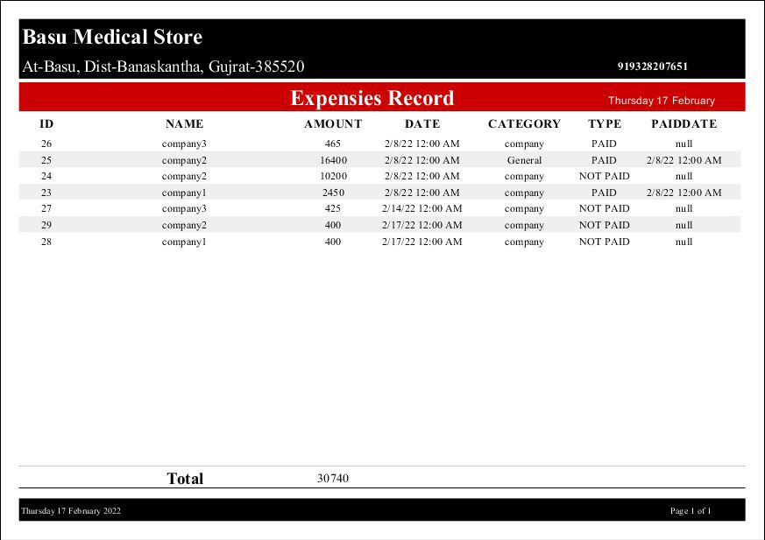

* 1. Credit :

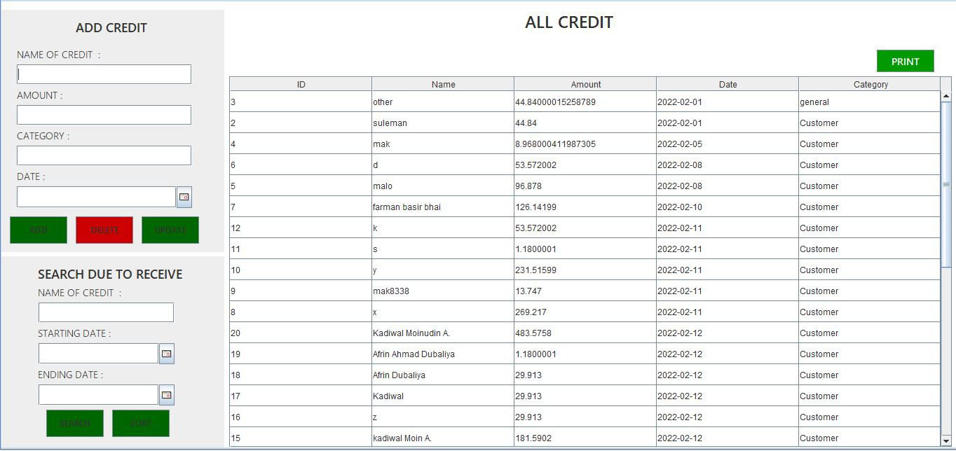

* 1. Print Credit Statement :

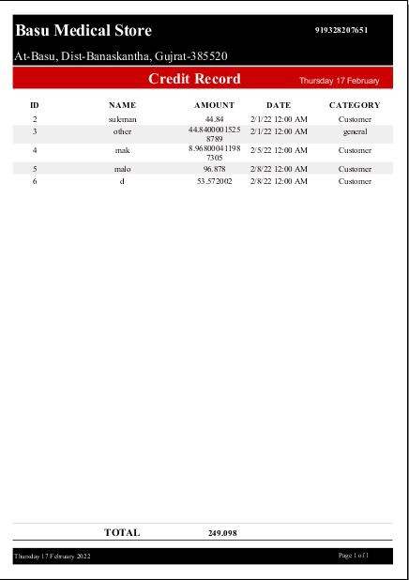

* 1. Payment :

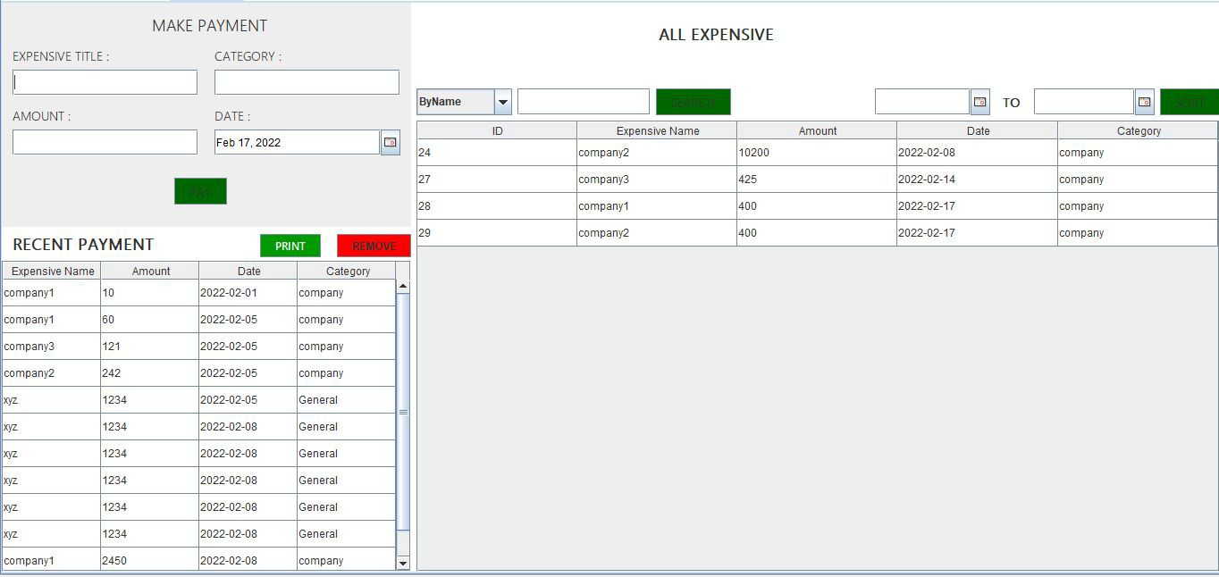

* 1. Make Payment Invoice :

1. Settings :